


Rollback Process Document


Document Control Information
Document Information
Document Name | Rollback Process Document
Project Name | Humana Salesforce DevOps
Client | Humana
Document Author | Krishna Prasad Polukonda
Document Version | 1.0
Document Status | Pending
Date Released | 7/27/2023
Document Edit History
Version | Date | Additions/Modifications | Prepared/Revised by
Document Review/Approval History
Date | Name | Organization/Title | Comments

Table of Contents
1. Rollback Process Document 5

Introduction

This document will helps us step by step process in handling the Rollback feature with guided screens for the workflow.

Rollback Steps
  - Promotional Level Rollback
Below are the steps that are involved in rollback based on the Promotional Level.
Promotional Level Rollback Steps:
- GoTo User Stories Select the US which are needed to be promoted to prod.
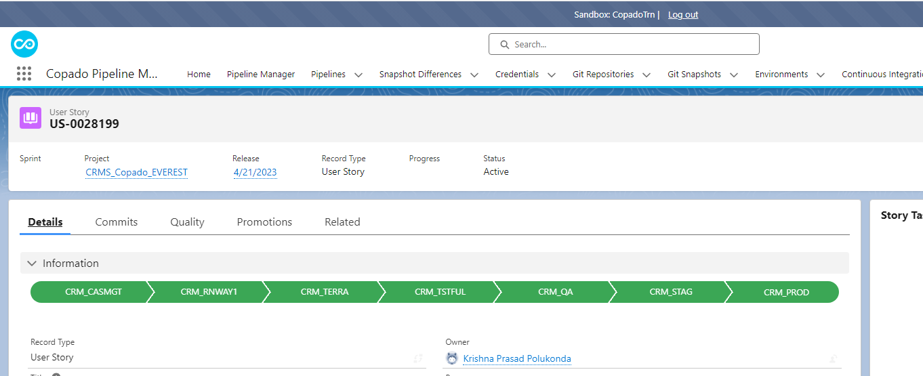
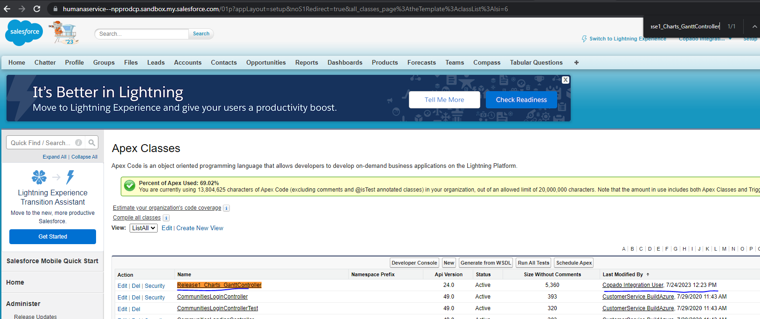
- Upon Completing the Promotion on the US Rollback will be enabled which is related to that promotion from Stag to Prod.
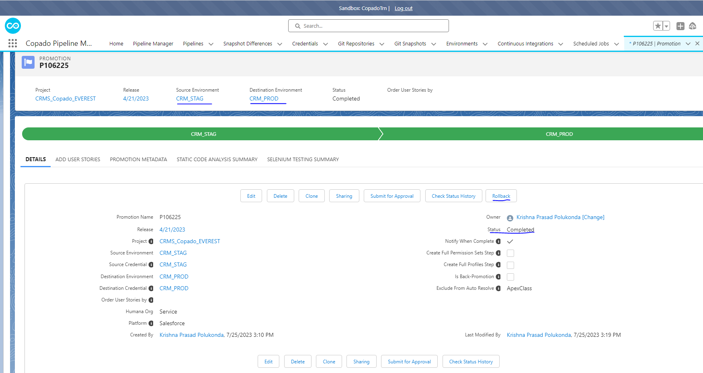

- Up on Clicking on Rollback Button where you can see all the metadata related to that promotions for which you can select/unselect the metadata which you would like to rollback from that.
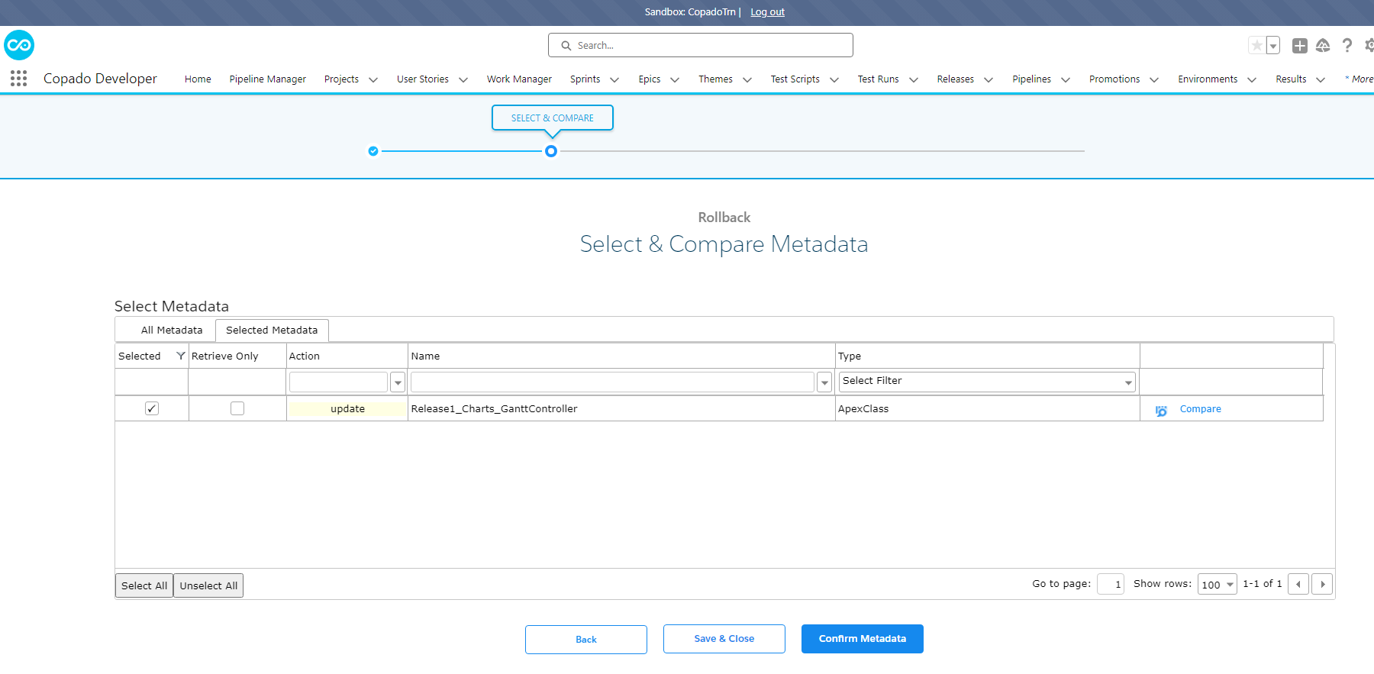

- Once the metadata is being confirmed Click on confirm Metadata Button
- Upon that you would have ability to Validate the Deployment before deploying.
- We will have ability to add any pre/post deployment steps needed for the rollback.
- We can also add Quality agtes if we need to run for the rollback using Go to Advanced Deployment button.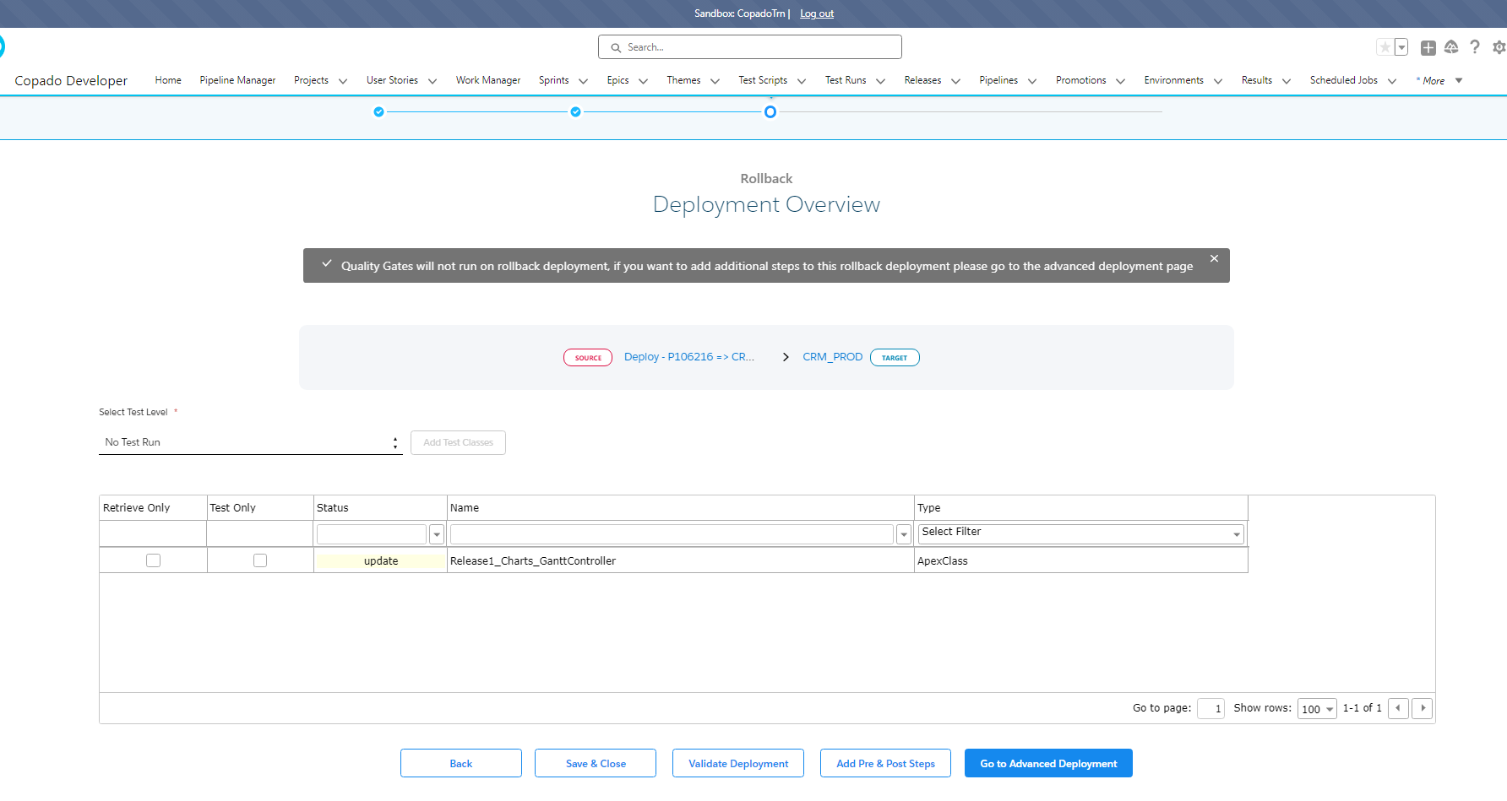
- If you ran the validation Steps To Move forward you need to click on “Start Deployment” to run the actial rollback deployment.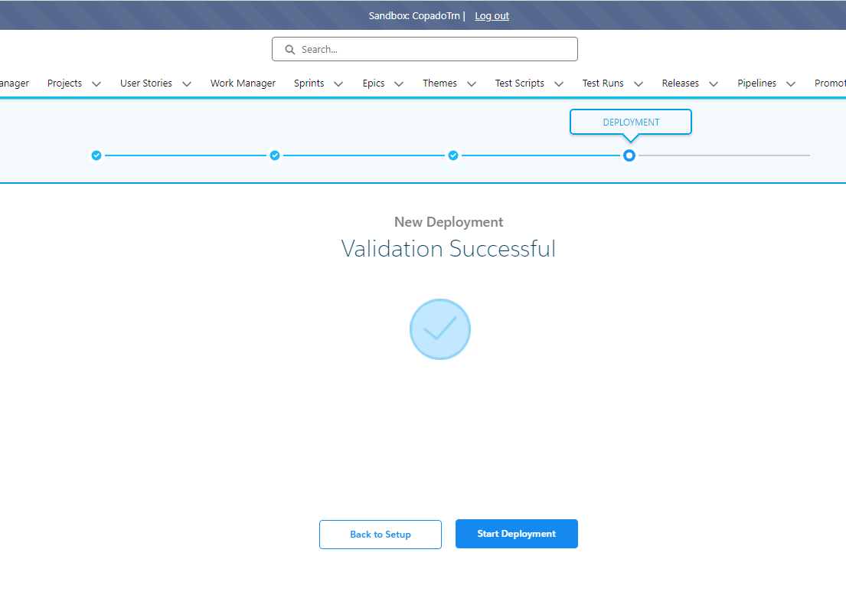
- After the deployment rollback completion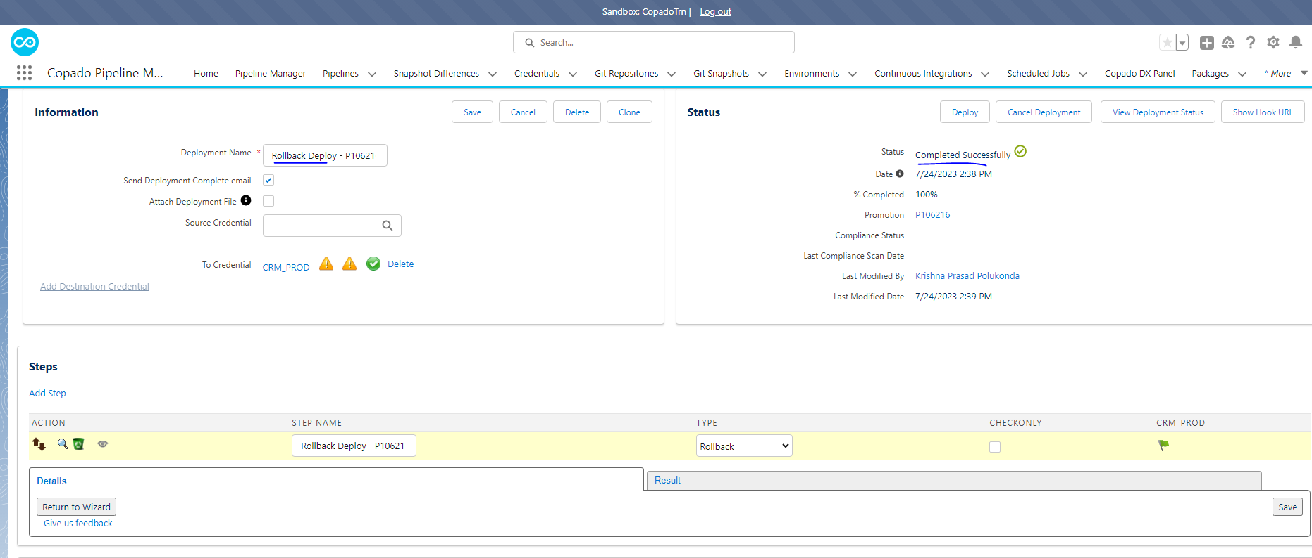

  - Backup Repo Level Rollback Using Commit snapshot (not recommended by E3 Copado)
Below are the steps that are involved in rollback based on the Promotional Level.
After Deplying the US to PROD:
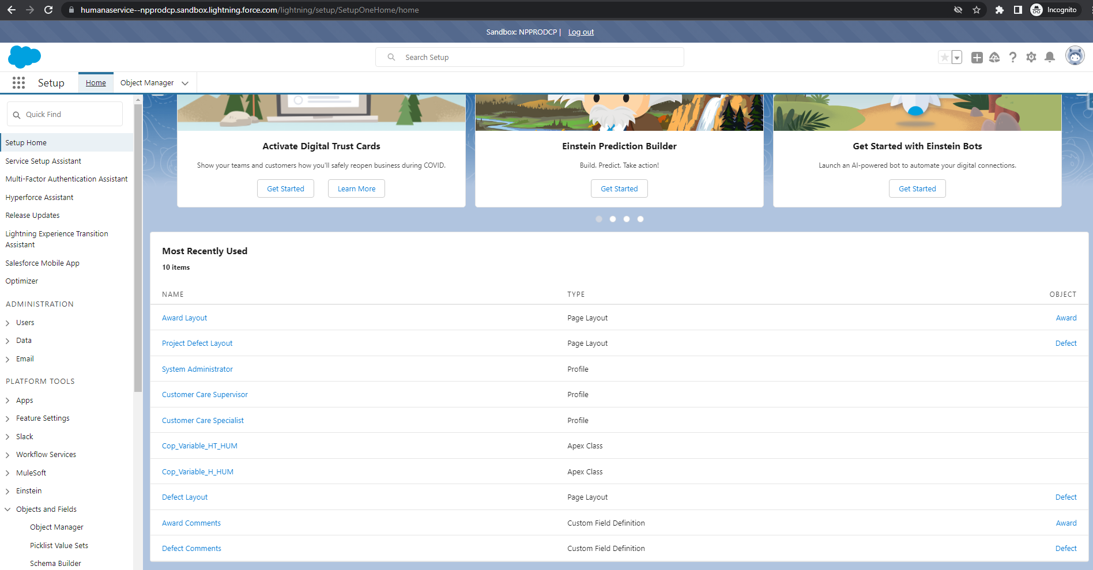
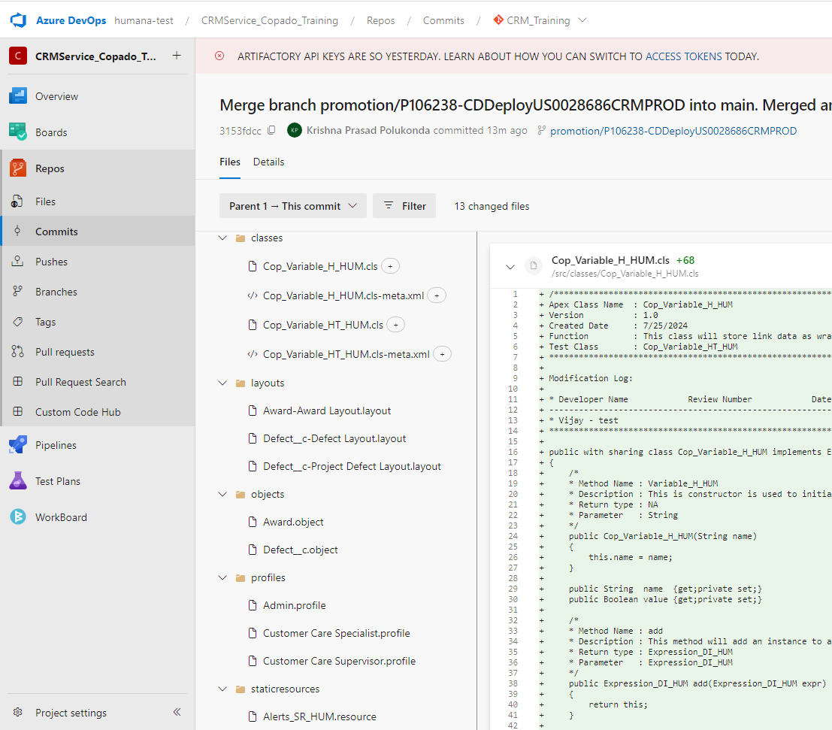
Pre-requisite: GIT Snapshot needs to be taken before the deployment which is being taken from the certification process.
Step 1: Rollback In Salesforce Org:
- Goto Git Repository Backup record click on Create Deployment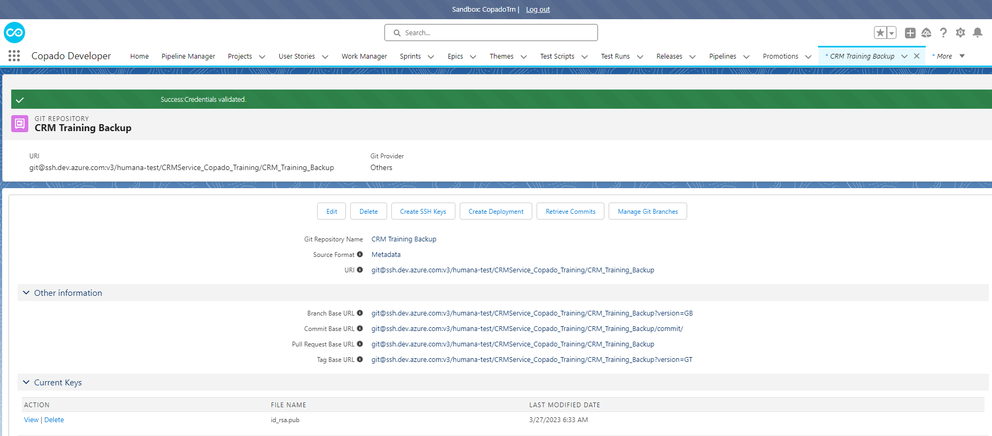

- On Deployment Screen you need to Add from which commit to which commit you need to deploy for this rollback: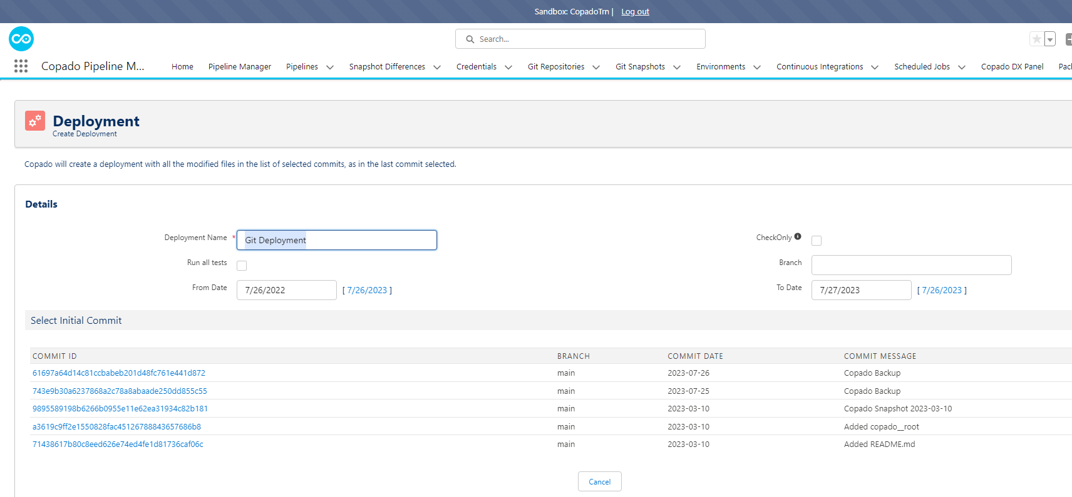

Starting Commit : Oldest Commit

Ending Commit: To Latest Commit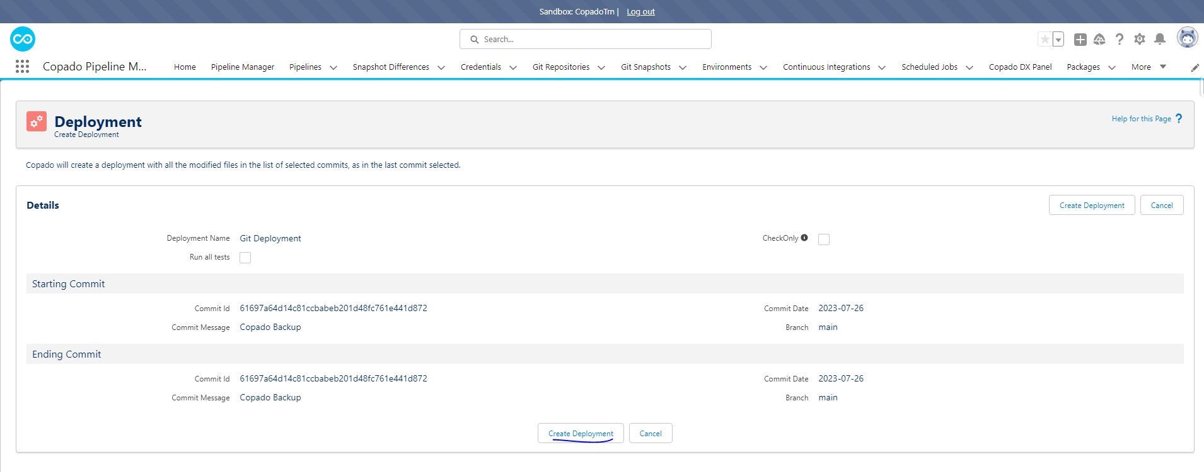

- Under Deployment Add Filed which are need to be rollbacked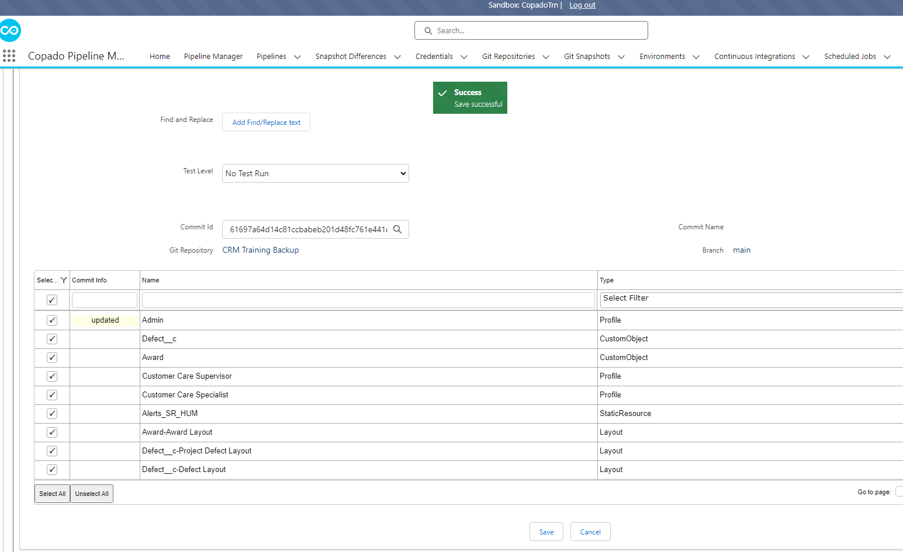

- Need to add the Source and To Credentails to have the metadata to get deployed.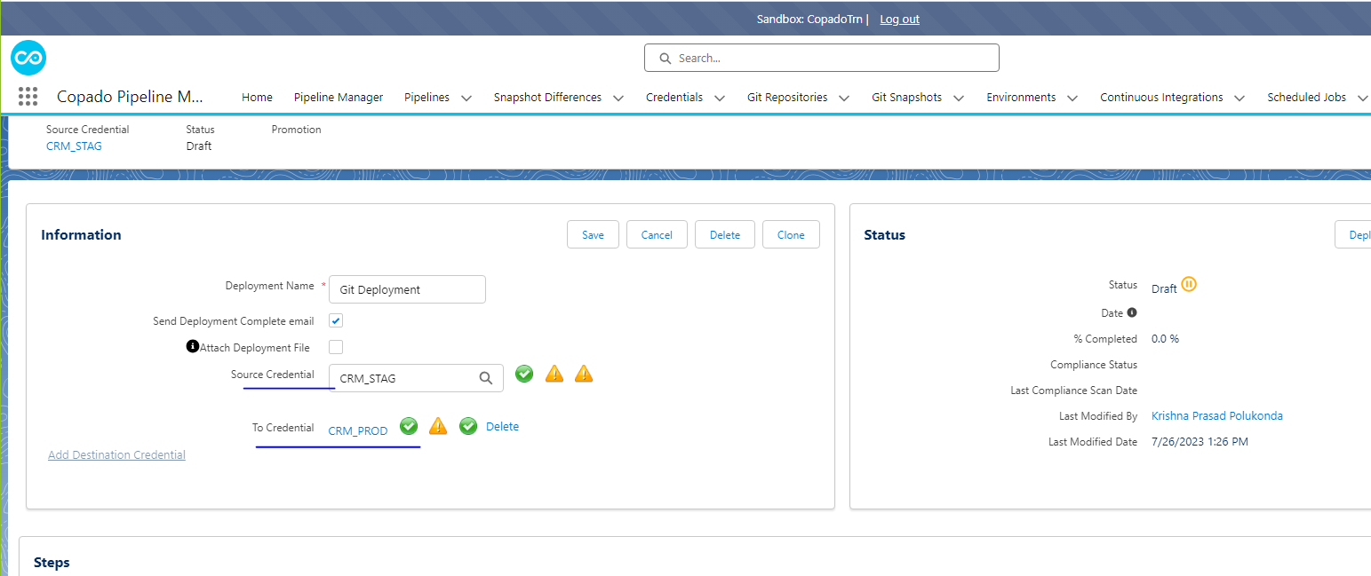

- Need to add manually deployment steps if you have 2 commits one with updates and other with destructive to do the deployment rollback.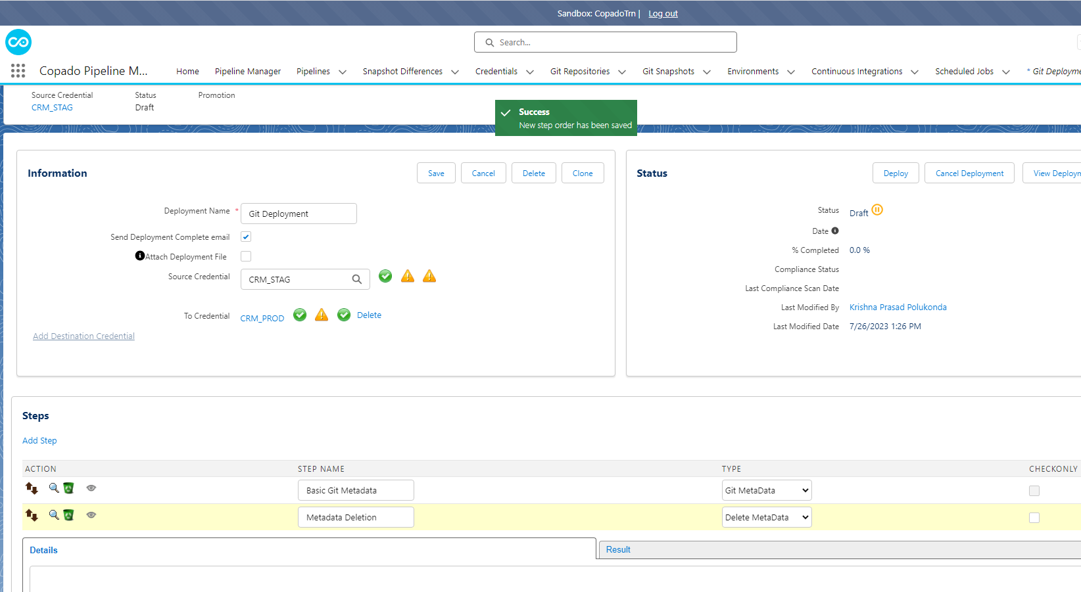

Step 2: Commit Level Rollback Steps Post Deployment
- GoTo Git Repository Select the Project repo and go to PROD GIT Snapshot.
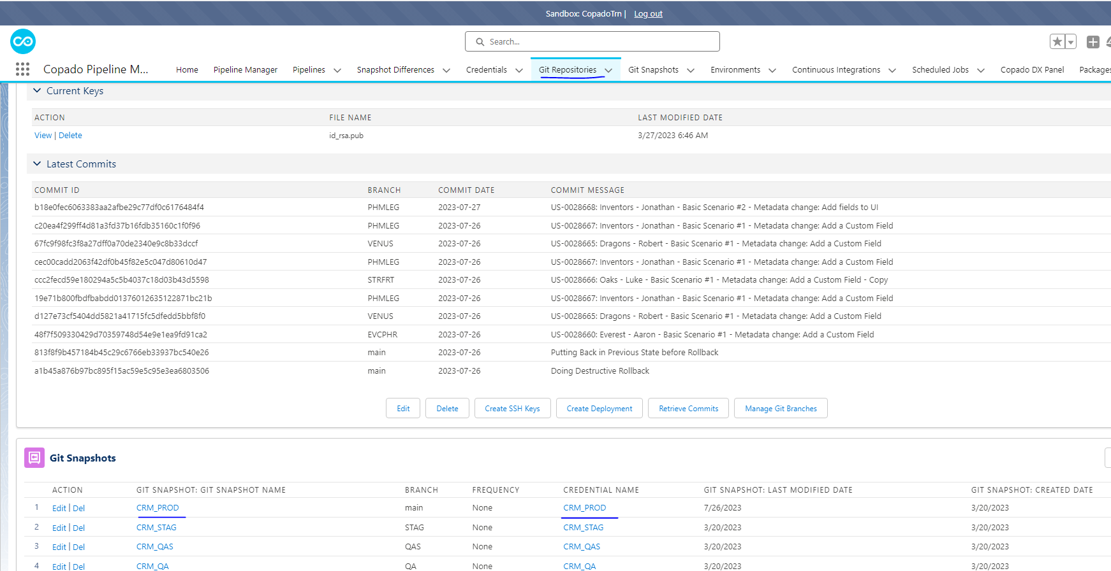
- After clicking on PROD Snapshot
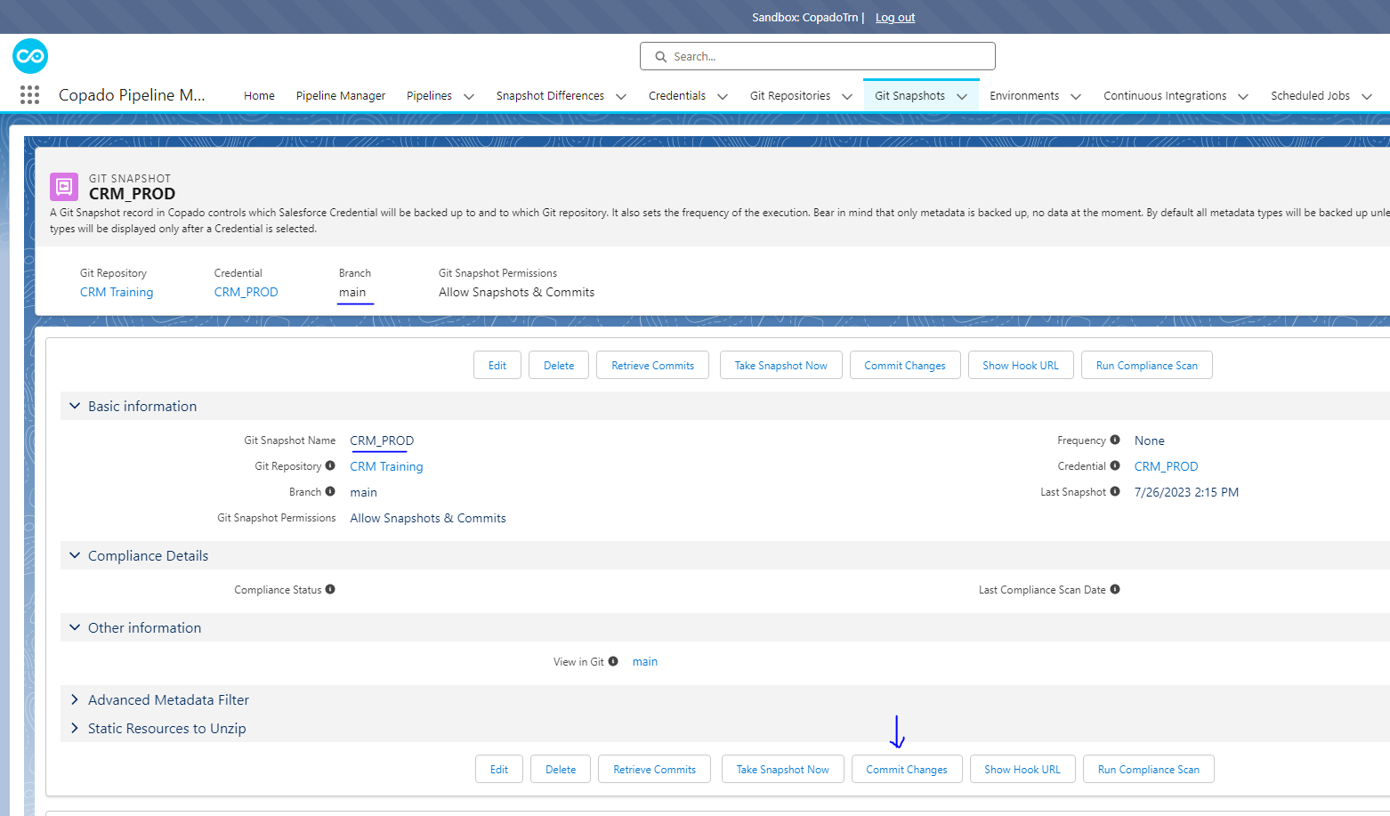

- After Clicking on commit Changes:
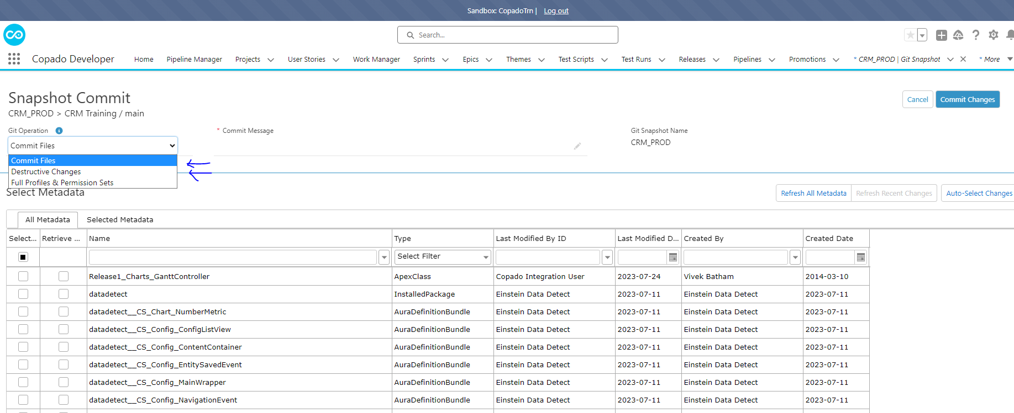

NOTE: If the Rollback contains deletions and update then we need to do 2 commits which needs to separately committed. If the metadata doesn’t show up you can do that using “Add Row” button with the name and type of the metadata that needs to be added for this rollback.
Commit Changes:
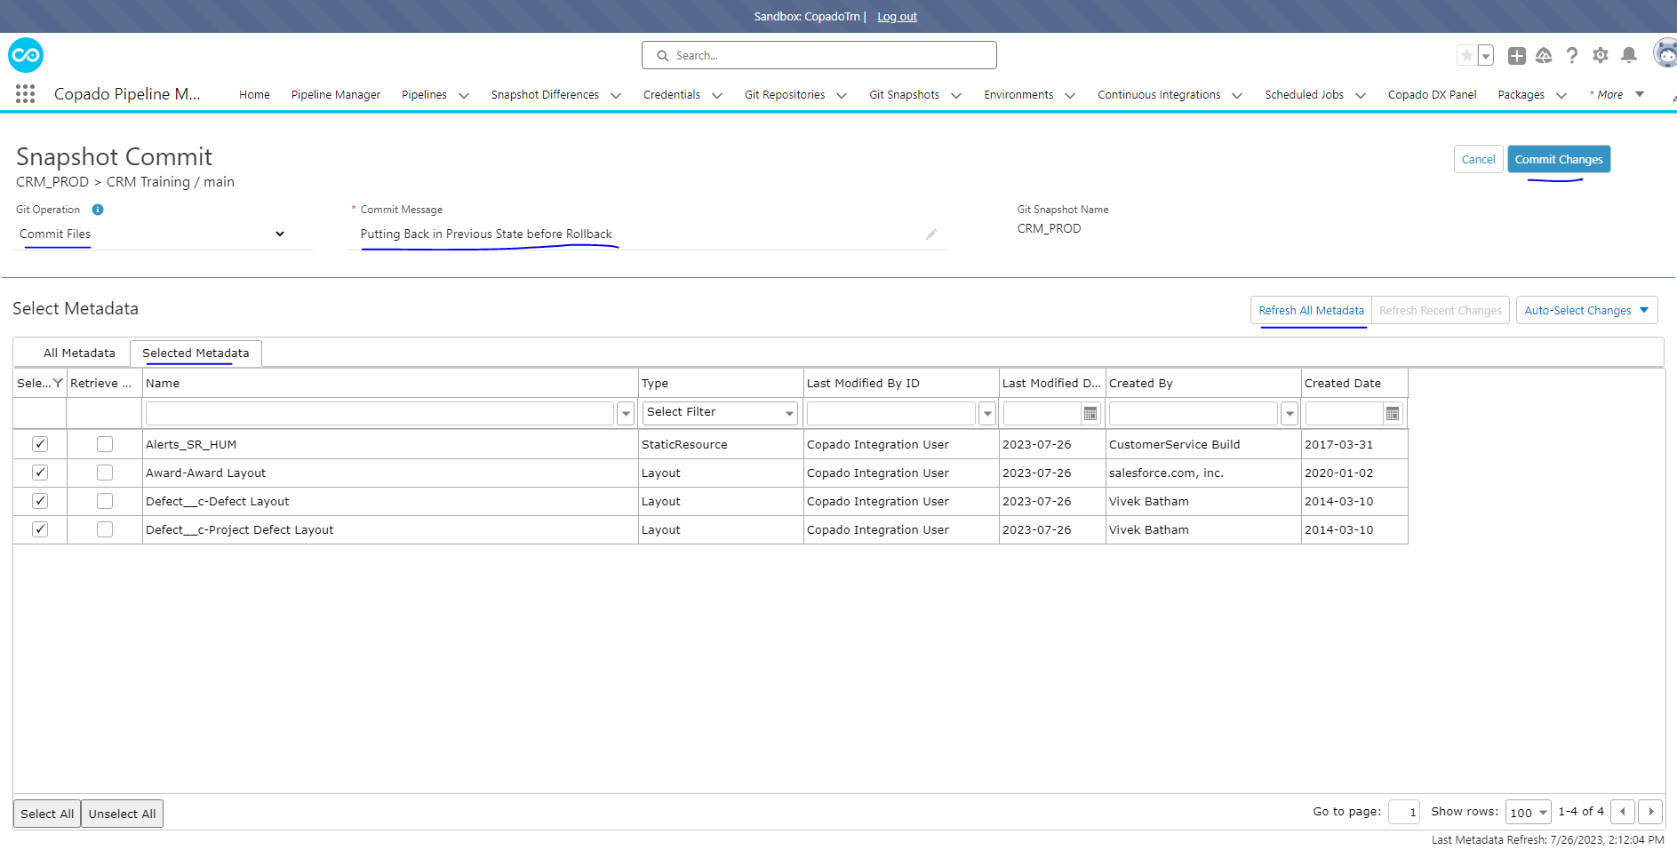
Destructive Changes:
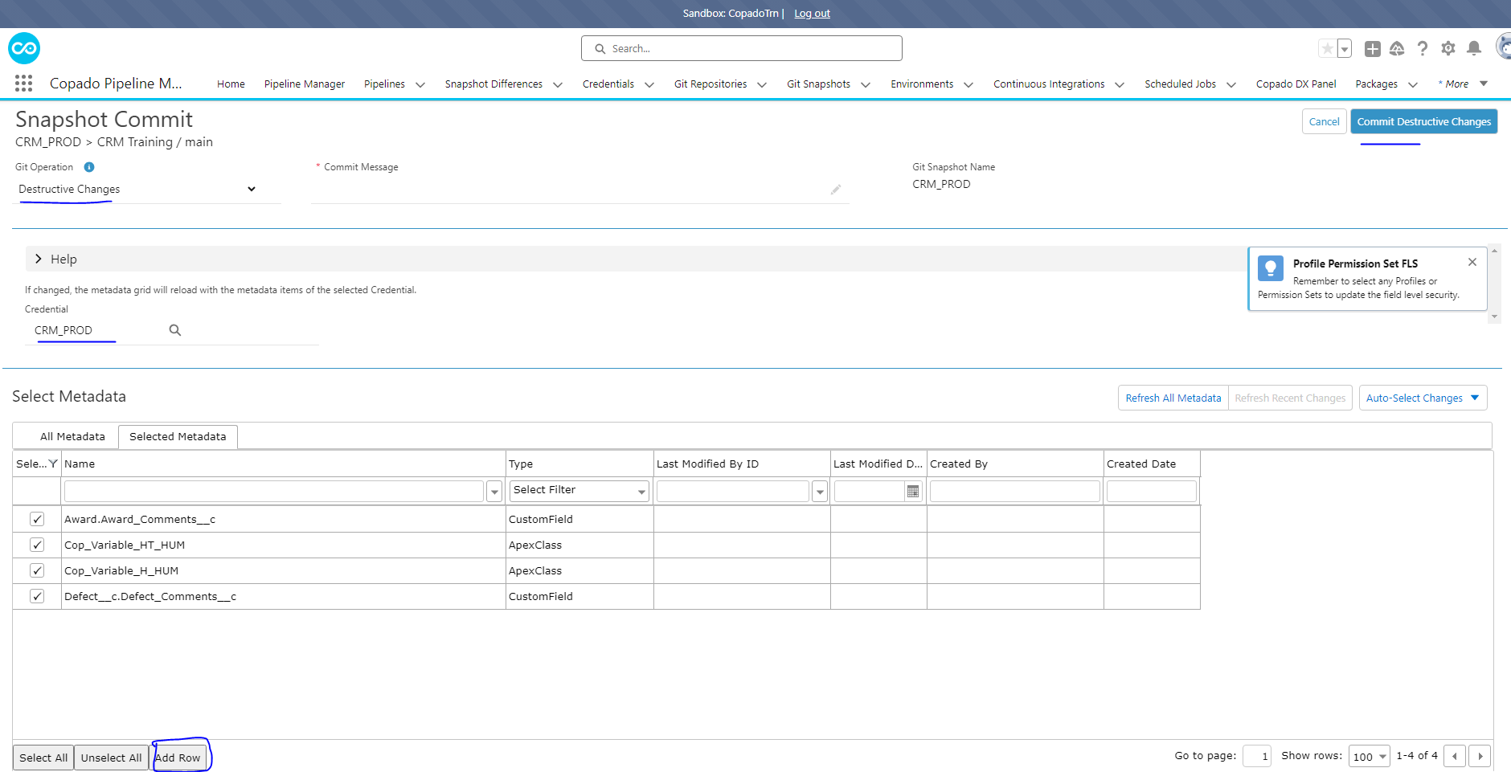

- After doing the commits you should be seeing in the GIT Snapshot in the PROD record.
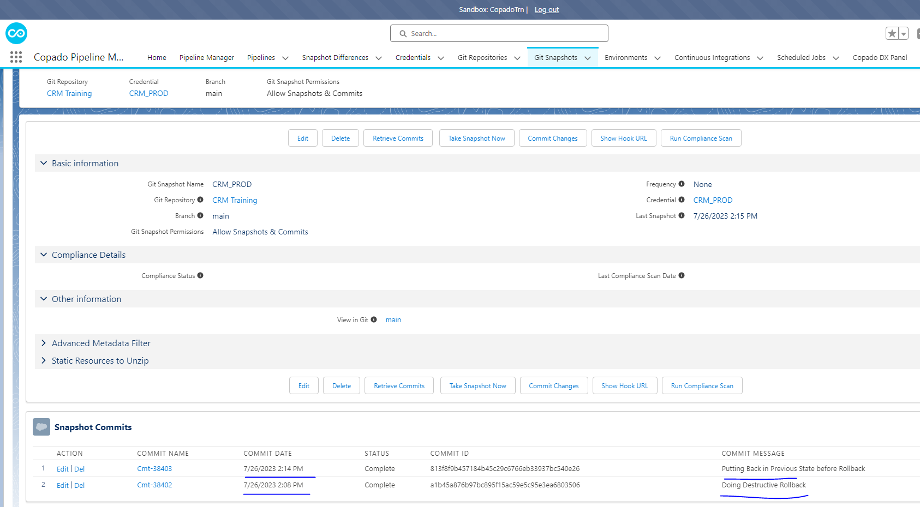

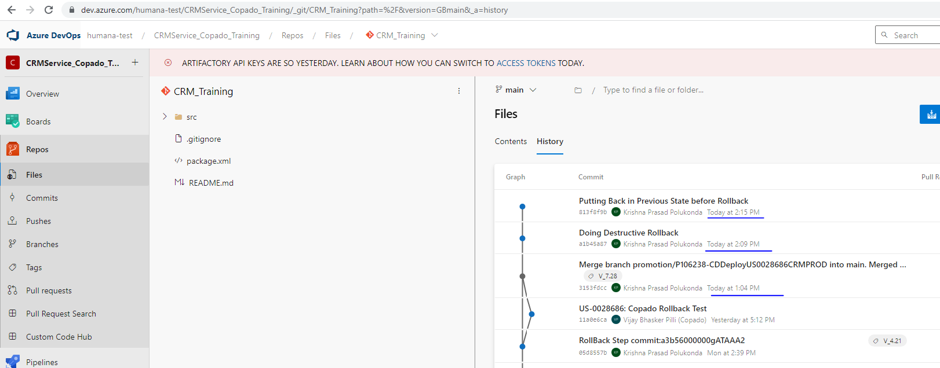

NOTE: Once the Rollback is complete in PROD all those needed to be rollbacked in lower orgs based on teams requirement but if they need to keep the branches in sync a new User Story needs to be created which will be repointed to their PROD-1 as base branch and commit their rollback change and needs to get them deployed till PROD-1 and close the story. By doing this exercise all the lower branches will be in SYNC with main to avoid any conflicts for other US commits.
After Creating a Rollback User Story Click on Commits Click on Advanced Button
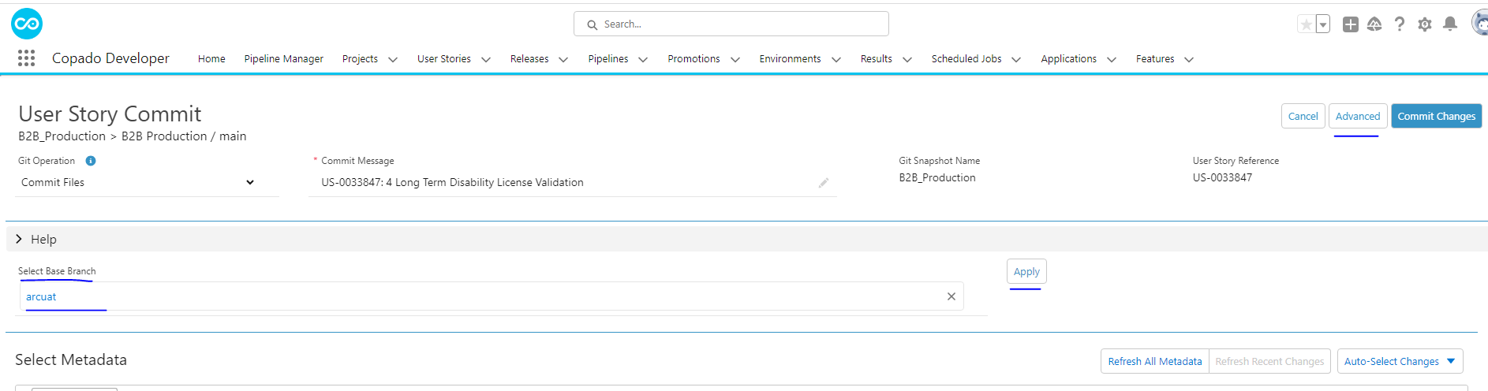

Add all the rollbacked components and then commit and deploy them all the way to PROD-1.

